Contributors | _ _ _ _ _ Teacher
Lesson Title |  |  |  |  | Version | 1 | Time | __M
Semester |  | Grade/Age/Level |  | Textbook
Week |  | Number of Sts. | __+ | Unit & Module
Topic
Target Language

Lesson Goals:
1.

2.

3.

Materials Needed
Computer
Whiteboard
USB
PPT
Blackboard
Chalk

Step (Presentation/Practice/ Production/ Review / Reward) | Actions | Anticipated Problems + Solutions | Time
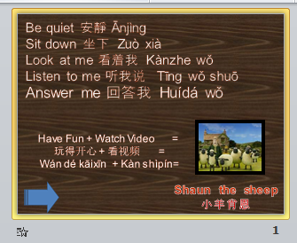  Warmer | Greet Students.  Go over class rules.  Play song or game from previous class as a review.  Put Students into teams based on their seating columns. | N / A | 5 min.
Presentation |  |  | __ min
Practice |  |  | __ min
Practice | NOTE:  To add more sections to your lesson plan  right-click on the mouse, scroll to insert and select ‘insert rows below’. |  | __ min
Production |  |  | __ min
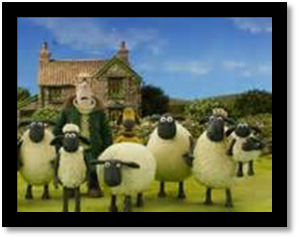  Reward | Tally the total points of each team and congratulate the team with the most points.  If the students have been well-behaved and have completed all the lesson ppt slides, they can be rewarded with a funny video. | N / A | 5min

